**CH 5**

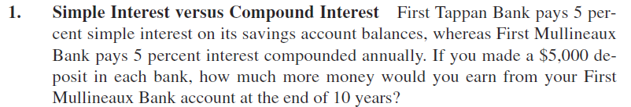

FTBank =5000 +5.000 x 0,05 x 10= 5.000 + 2500 = 7.500

FMBank

FV=PV x (1+r)t

FV=5.000 x (1+0,05)10 =8.144,47

8.144,47 – 7.500 = 644,47

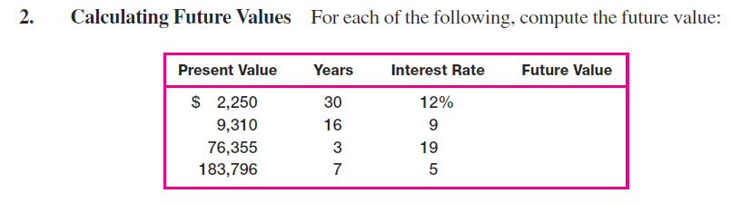

FV=PV x (1+r)t

FV=2.500 x (1+0,12)30 = 67.409,82

FV=9.310 x (1+0,09)16 = 36963,55

FV=76.355 x (1+0,19)3 = 128.670,32

FV=183.796 x (1+0,05)7 = 258.619,43

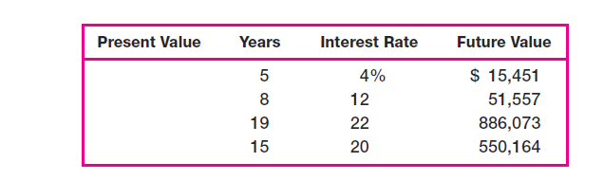

FV=PV x (1+r)t

15.451 = PV x (1+0,04)5= 12.699,59

51.557 = PV x (1+0,12)8= 20.823,00

886.073 = PV x (1+0,22)19= 20.260,00

550.164 = PV x (1+0,20)15= 35.706,00

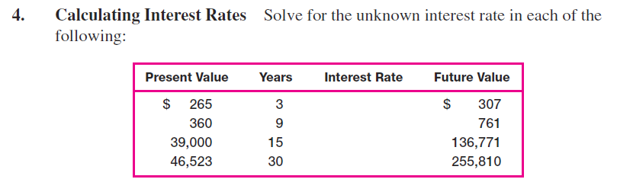

FV=PV x (1+r)t

307 = 265 x (1+ r)3

307/265 = (1+r)3

1,1585 = (1+r)3

3√ 1,1585 = 1+r

1,05026 = 1+r

r = 5,026%

761 = 360 x (1+ r)9

r = 8,67%

136.771 = 39.000 x (1+ r)15

r = 8,72%

255.810 = 46.523 x (1+ r)30

r = 5,85%

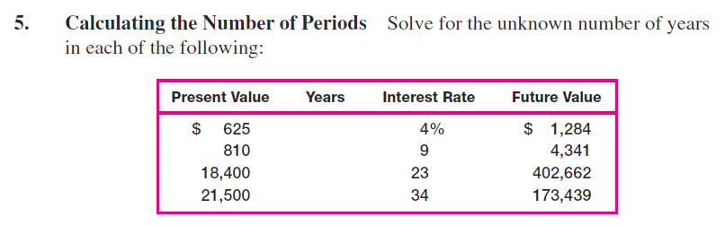

FV=PV x (1+r)t

1.284 = 625 x (1+ 0,04)t

(1+ 0,04)t = 1.284/625

1,04t = 2,0544

log 1,04t = log 2,0544

t x log 1,04 = log 2,0544

t = log 2,0544 / log 1,04

t = 0,31268/ 0,01703 = 18,36

4.341 = 810 x (1+ 0,09)t

t = 19,48

402.662 = 18.400 x (1+ 0,23)t

t = 14,91

173.439 = 21.500 x (1+ 0,34)t

t = 7,13

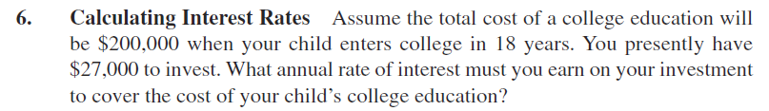

FV=PV x (1+r)t

200 000 = 27 000 x (1+ r)18

7,4074 = (1+ r)18

18√ 7,4074 = 1+r

1,1176 = 1+r

r = 0,11767

r = 11,77 %



FV=PV x (1+r)t

2 = 1 x (1+ 0,06)t

(1+ 0,06)t = 2

1,06t = 2

log 1,06t = log 2

t x log 1,06 = log 2

t = log 2 / log 1,06

t = 0,30103/ 0,02535 = 11,88 year

2 = 1 x (1+ 0,06)t

(1+ 0,06)t = 4

1,06t = 4

log 1,06t = log 4

t x log 1,06 = log 4

t = log 4 / log 1,06

t = 0,60206/ 0,02535 = 23,75 year



FV=PV x (1+r)t

40 000 = 12 000 x (1+ r)15

3,3333 = (1+ r)15

15√ 3,3333 = 1+r

1,08357 = 1+r

r = 0,08357

r = 8,357 %

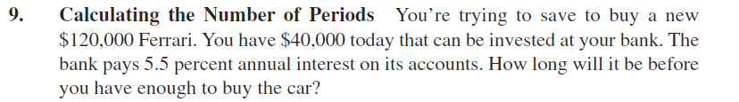

120 000 = 40 000 x (1+ 0,055)t

(1+ 0,055)t = 3

1,055t = 3

log 1,055t = log 3

t x log 1,055 = log 3

t = log 3 / log 1,055

t = 0,4771/ 0,0232 = 20,56 year

**CH 6**

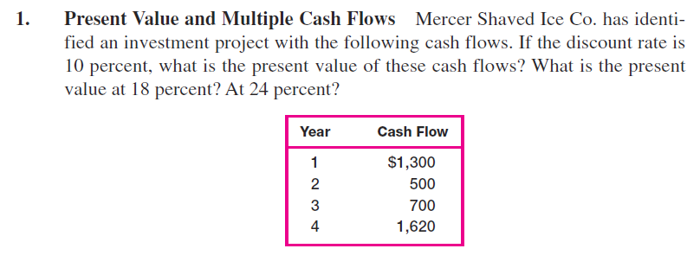

PV=1300/(1.1)1+500/(1.1)2+700/(1.1)3+1620/(1.1)4=

1181.82+413.22 + 525.92+ 1106.48 = 3227.44

PV= 1300/1.181+500/1.182+700/1.183+1620/1.184=

1101.695+359.092+426.042+835.58= 2722.40

PV= 1300/1.241+500/1.242+ 700/1.243+ 1620/1.244=

1048.39+325.18+367.17+685.22 =2425.96

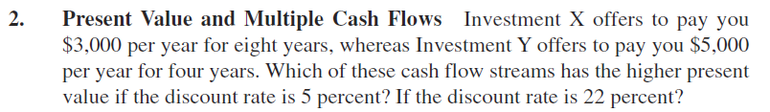



When the discount rate is 5%:

**AnPV (X)**= 3000*{1-[1/1,058]}/0,05= 3000*{1-[1/1,4775]}/0,05=

= 3000*{1-0.67684}/0.05=3000*6.46321=**19.389,64**

**AnPV (Y) =** 5000*{1-[1/1.054]}/0.05=5000*{1-[1/1.21551]}/0.05=

= 5000*{1-0.8227}/0.05=5000*3.54595=**17.729,75**

At a discount rate of 5%, the present value of investment X is higher, i.e. **19.389,64>17.729,75**

When the discount rate is 22%:

**AnPV (X)**= 3000*{1-[1/1,228]}/0,22= 3000*{1-[1/4,9077]}/0,22=

= 3000*{1-0.20376}/0.22=3000*3,61927=**10.857,81**

**AnPV (Y) =** 5000*{1-[1/1.224]}/0.22=5000*{1-[1/2,21533]}/0.22=

= 5000*{1-0.4514}/0.22=5000*2,49364=**12.468,20**

At a discount rate of 22%, the present value of investment Y is higher, i.e. **12.468,20>10.857,81**

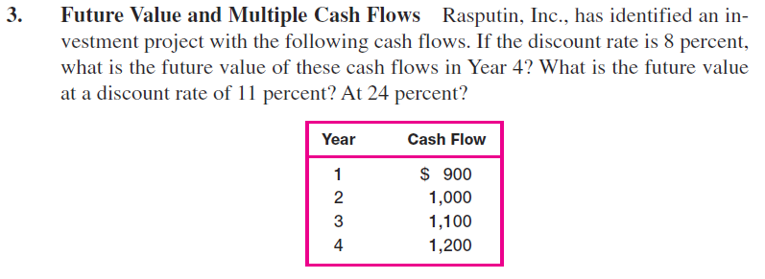

When the discount rate is 8%

**FV**= 900*1.084+1000*1.083+1100*1.082+1200*1.08=

= 1224,44+1259,71+1283,04+1296 = **5.063,19**

When the discount rate is 11%

**FV**= 900*1.114+1000*1.113+1100*1.112+1200*1.11=

= 1366,26+1367,63+1355,31+1332=**5.421,20**

When the discount rate is 24%

**FV**= 900*1.244+1000*1.243+1100*1.242+1200*1.24=

= 2127,79+1906,62+1691,36+1488=**7.213,78**

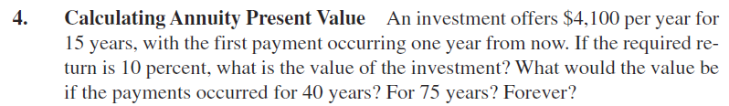

Investment value if paid in 15 years:

**AnPV**=4100*{1-[1/(1+0,1)15]}/0,1=4100*{1-[1/4.17725]}/0,1=

=4100*{1-0.23939}/0,1=4100*7.6061=**3.118,93**

Investment value if paid in 40 years:

**AnPV**=4100*{1-[1/(1+0,1)40]}/0,1=4100*{1-[1/45,25926]}/0,1=

= 4100*{1-0,022095}/0,1=4100*9,779051=**40.094,11**

Investment value if paid in 75 years:

**AnPV**=4100*{1-[1/(1+0,1)75]}/0,1=4100*{1-[1/1271,895371]}/0,1=

= 4100*{1-0,00078623}/0,1=4100*9,992177=**40.967,93**

The value of the investment if paid forever

**PrPV**=4100/0,1=**41.000**





AnPV= 20 000; t =12 years ; r =8 %

20 000=C*{1-[1/1,0812]}/0,08

**C**=20 000/{1-[1/1,0812]}/0,08=20 000/{1-[1/2,51817]}/0,08=

= 20 000/{1-0,397114}/0,08=20 000/7,53608=**2653,90**

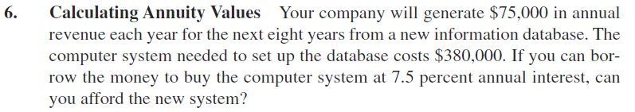

**AnPV**=75 000*{1-[1/(1+0,075)8]}/0,075=75 000*{1-[1/1.783478]/0,075=

= 75 000*{1-0,560702}/0,075= 75 000*5,8573=**439.297,50**

Will be able to purchase a new system because **439 297.50> 380 000**

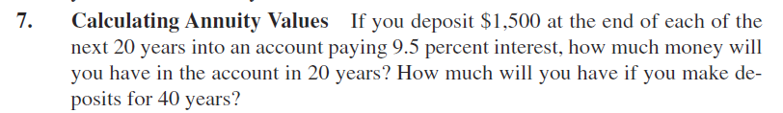



After 20 years.

**AnFV**=1500*{1,09520-1}/0.095= 1500* {6,14161-1}/0,095=1500*54,1222=**81.182,35**

After 40 years.

**AnFV**=1500*{1,09540-1}/0.095=1500* {37,719399-1}/0,095=1500*386,51999=**579.779,99**

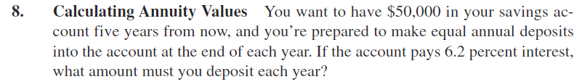



t= 5 years. ; FV = 50 000; r=6.2 %; C = ?

50 000=C*{1.0625-1}/0,062  
50 000= C*5.65965

C=50 000/5.65965 = **8834.47**





AnPV= 35 000; t =7 m.; r=10 % C = ?

35 000=C*{1-[1/1,17]}/0,1

35 000=C*{1-[1/1,94871]}/0,1

35 000 = C* 4,86842

**C**= 35 000/4,86842 = **7.189,19**

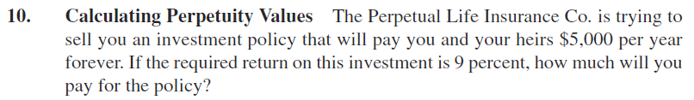

C=5 000; r=9 %

**PrPV**= 5000/0.09= **55.555,56**

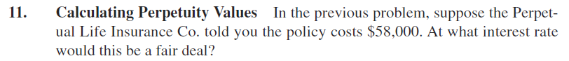

PrPV=58 000; C= 5000

58000=5000/r

**r**= 5000/58000 = 0.0862 -> **8.62 %**

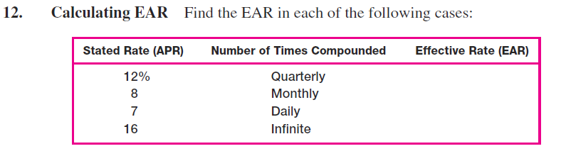

EAR = [ 1+ (APR/m )]m – 1

[1+(0.12/4)]4-1=1,034-1=1,1255-1=0,125509 or **12.55 %**

[1+(0,08/12)]12-1=1.006712-1=1,08299-1=.0,0829 or **8,3%**

[1+(0,07/365)]365-1=1,00019365-1=1,0725-1=0,0725 or **7,25%**

If infinite EAR = e APR -1

e0.16-1=2,718280,16-1=1,1735-1=0,1735 or **17,35 %**

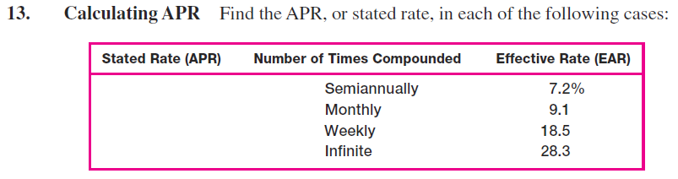

EAR = [ 1+ (APR/m )]m – 1

0,072=[1+(APR/2)]2-1;

2√ 1,072 =1+0,5APR;

0.5APR=1,03537-1=0,03537

APR= 0,0707 or **7,07 %**

0,091= [1+(APR/12)]12-1;

12√1,091 =1+(APR/12);

APR/12=1.00728-1=0.00728

APR=0,00728*12= 0,0874 or **8,74 %**

0,185=[1+(APR/52)]52-1;

52√1,185 =1+(APR/52);

APR/52= 1,00326 -1=0,0026

APR=0,00326*52=0,17 or **17%**

eAPR-1=0,283;

eAPR=1,283;

APR*ln(e)=ln (1,283);

APR=0,2492 or **24.92 %**

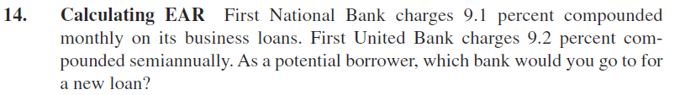

EAR = [ 1+ (APR/m )]m – 1

FN: R=9.1%; m=12 FUB: r=9.2%; m=2

**FN:** EAR= [1+(0.091/12)]12-1=1,007612-1=1,09489 -1=0,09489 or **9.489%**

**FUB:** EAR= [1+(0.092/2)]2-1=1,0462-1=1,094116-1=0,094116 or **9.4116 %**

Bank FUB because interest rates are lower **9.489% > 9.4116 %**

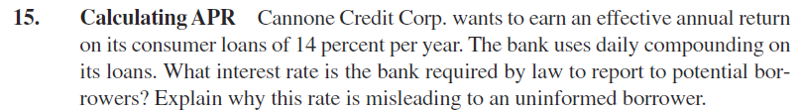

EAR = [ 1+ (APR/m )]m – 1

EAR=14 %, m=365, APR = ?

[1+(APR/365)]365-1=0.14

[1+(APR/365)]365=1.14

365√1.14 = [1+(APR/365)]

1.000359 = [1+(APR/365)]

APR/365=1.000359-1=0.000359

**APR=**0.000359*365=0.131035 arba **13.1035 %**